CASSANDRA ASSIGNMENT:

1. CASSANDRA setup:

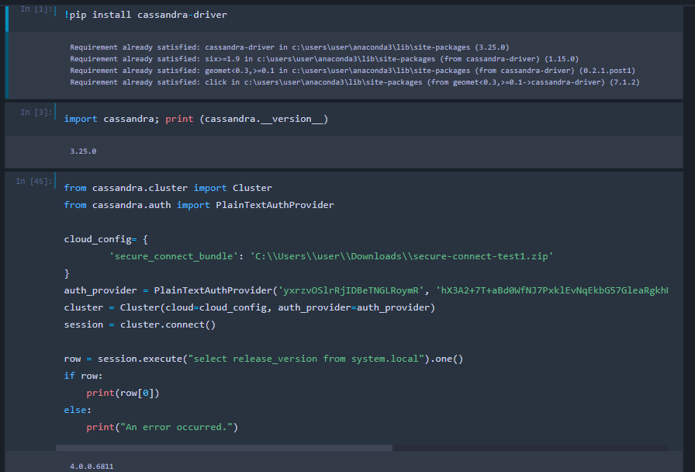

1. Note : Keyspace already created in the console:
2. Now create a table:

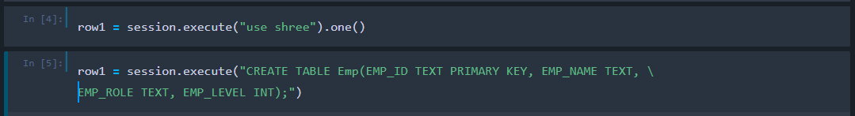

1. Insert a row:

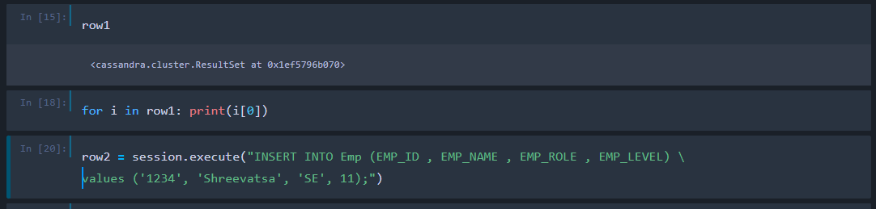

1. Insert more rows and output:

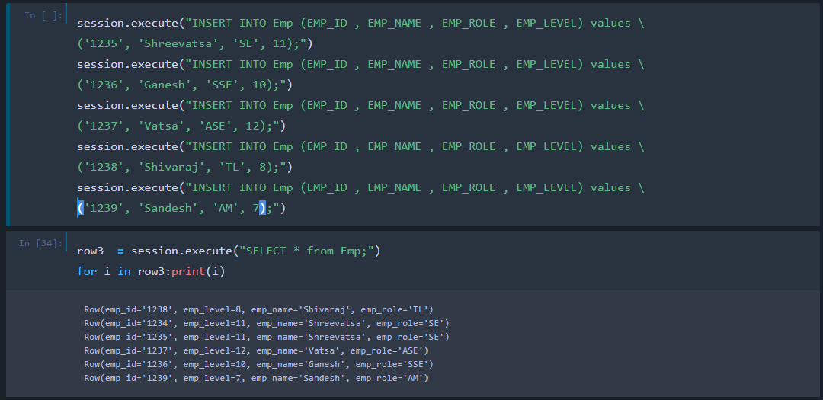

1. Get the Rows count:



1. Add new column named “Score”



1. Update Score = 71 for Emp ID 1235:

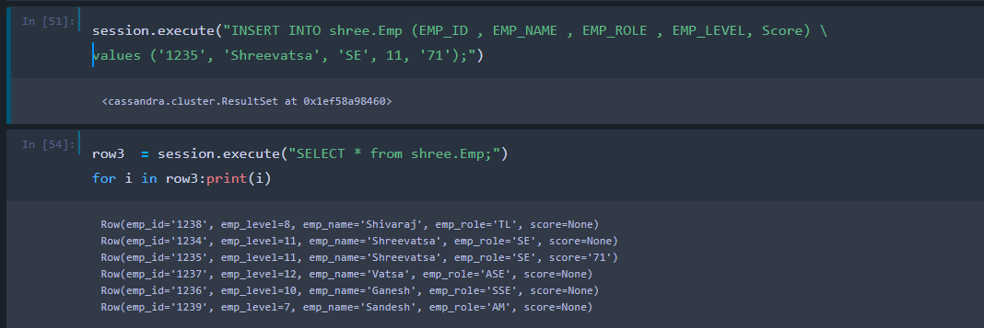

1. Update the scores for all entries:

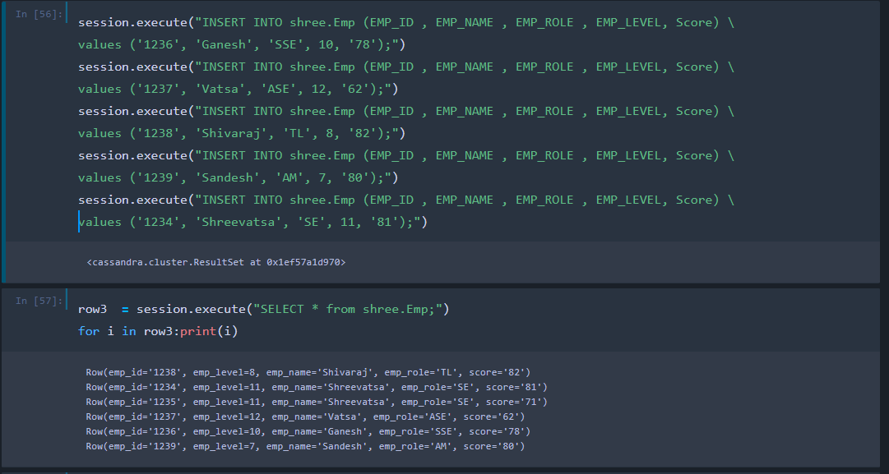

1. To find the minimum score:

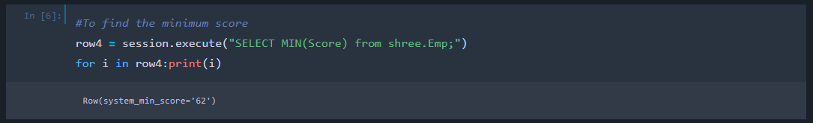

1. To Output the Max score of emp name:

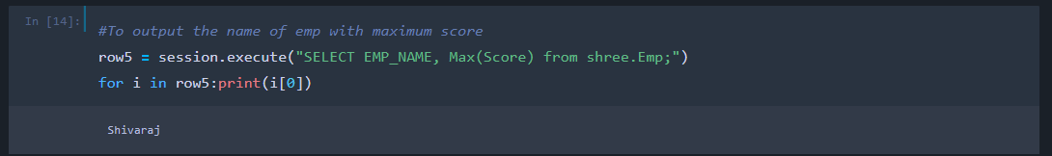

1. Add one more column named “Per Score” and add int valiues to t for all the entries.

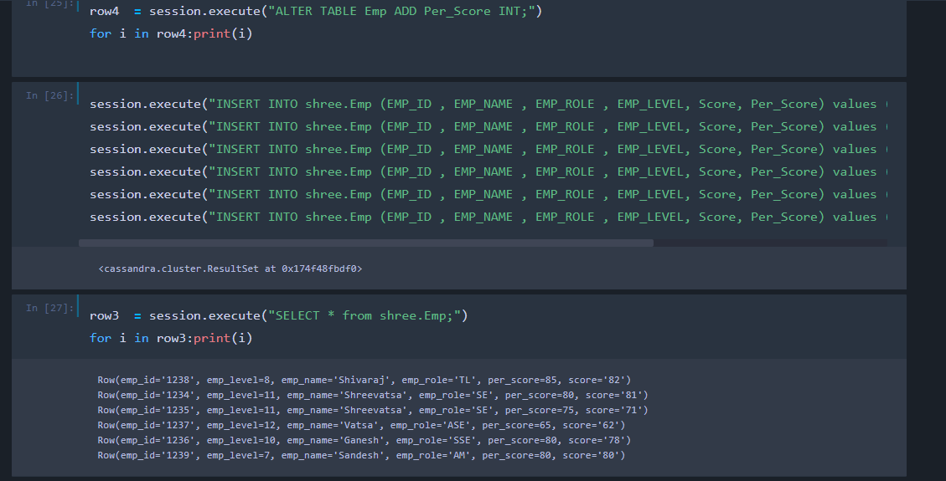

1. To find the sum of column “Per Score”

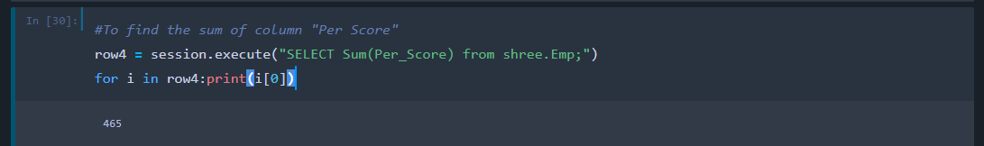

1. To find the average of Per Score:

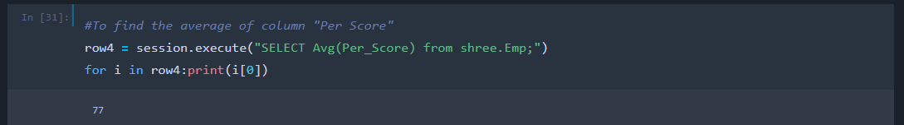

1. Print whole table:

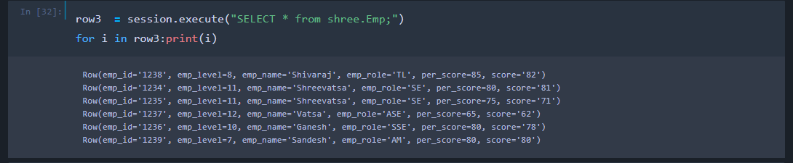

1. Show the table in CQL:

